Wire corrector systems for the compensation of the Long-Range Beam-Beam effects

O. Kester, Marco Marchetto

- Beam-Beam Long-Range Compensators with physical wires are considered a valuable option for HL-LHC to increase dynamic aperture at small crossing angles by compensating the nonlinear beam-beam effects.
- Prototype wires embedded in collimators in LHC have already demonstrated the potential of a wire corrector to reduce the tune spread and increase the dynamic aperture. Simulations of the TRIUMF beam physics group under Rick Baartman could confirm these effects.
- Experimentally, it was possible to reduce the crossing angle, without increasing the losses. That will reduce the irradiation on the final focussing triplets and background at the experiments.
- The wires thereby will allow for and estimated 3-5% improvement in integrated luminosity compared to baseline (crab cavities, round beams) including flat beams.

Systems of the wire corrector assembly (information from CERN group members of the beam-beam long-range corrector (BBLRC) collaboration member Adriana Rossi):
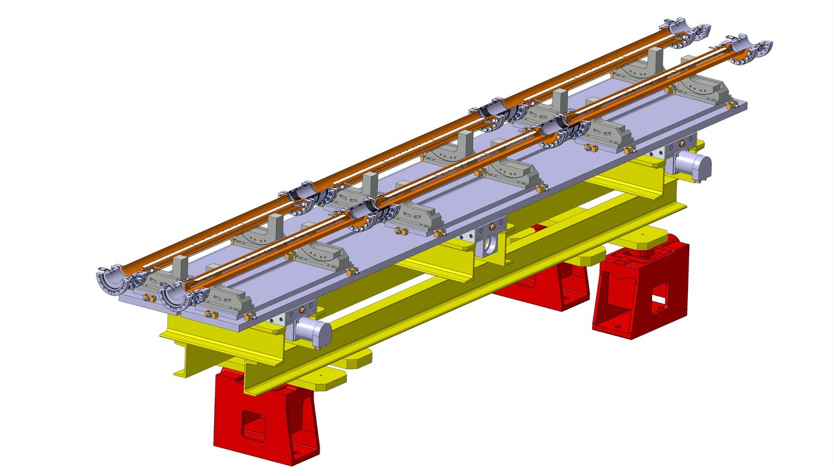

4 of these assemblies, each 4.5 m long, are required, two for each side of IP1 and IP5 of LHC.

System | Details
Vacuum chamber + wire | - 1 mm Mo wire brazed on a AlN ceramics, Cu backing, 6 m per assembly  - insulator and wire are mechanically clamped to a Cu-based housing (Cu due to RF impedance)  - Water cooling channel obtained by housing machining and cover welding. Cu half-shell welded to the housing.  - Commercial feedthrough connection carrying up to 185 A  - Stainless steel flange brazed to copper and then welded to vacuum chamber.  TRIUMF proposes and accessible vacuum chamber, but that’s still in discussion  - Ports for pumping and vacuum instrumentation will be required.
Mechanical tables | Support cradles required for precise alignment of the assembly itself
Frame and support | Rigid support structure required for the alignment against the beam, could be I-beams and CERN type frame bases
Beam position monitors and bellows (RF-modules) | The accurate beam-based alignment requires precise determination of the beam position with button pick-ups  In addition the BPMs are required for machine protection system  4 BPMs are required per assembly located in the connection modules at the extremities of the system
Connection modules | 4 connections including bellows and RF contacts, connecting the 6 tank/wire modules
Stepper motors, drives and controls electronic | 4 stepper motors, power drives and controls electronics are required per assembly to perform the automatic beam-based alignment.
Vacuum equipment | Separation of the wire system from LHC, valves according to LHC standard equipment, vacuum instrumentation
Power supplies  (contingency, will ask CERN to provide them if we run over budget) | The correctors must establish up to 450 A*m. A current of 150 A will be required in operations. 8 bipolar power supplies of 185 A, 20 V will provide maximum flexibility.

